**Samsung Brand USB**

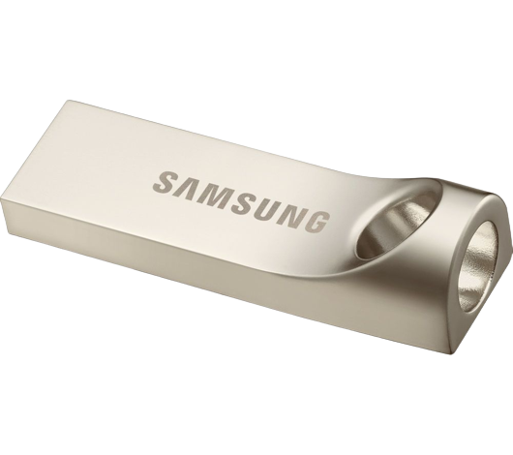 PKR 1,200 Pro

A Universal Serial Bus (USB) is a common interface that enables communication between devices and a host controller such as a personal computer (PC) or smartphone. It connects peripheral devices such as digital cameras, mice, keyboards, printers, scanners, media devices, external hard drives and flash drives. Because of its wide variety of uses, including support for electrical power, the USB has replaced a wide range of interfaces like the parallel and serial port.

A USB is intended to enhance plug-and-play and allow hot swapping. Plug-and-play enables the operating system (OS) to spontaneously configure and discover a new peripheral device without having to restart the computer. As well, hot swapping allows removal and replacement of a new peripheral without having to reboot.

**Size :** 8.5

**Speed :** 2,000rpm

**color:** Silver

**Species :** 16GB

**Brand Name :** samsung

**Products Status** Good New